3

**A. Algorithm Performance**

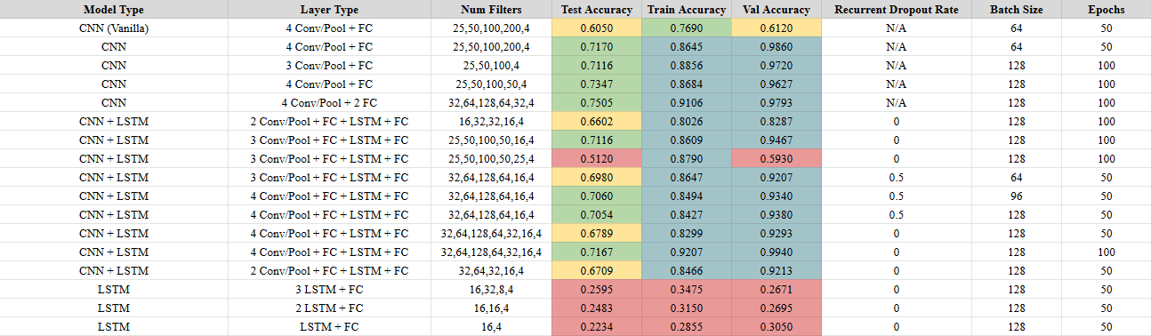

Table 1: Summarized Performance of All Algorithms Tested: Blue indicates performance higher than 80%, green indicates performance between 70 and 80%, yellow indicates performance between 60 and 70%, and red indicates sub 60% performance.

Table 2: Key Performance Cases of Spectrogram Model

Table 3: Key Performance Cases of 1 Subject Training and 1 Subject Testing

page4image46813040

**B. Model Architectures**

**B.1. Basic LSTM:**

Using raw input data (2115,1000,22), and going through three LSTM layers (32, 16, 8, output neurons respectively) with dropout = 0.5, no recurrent dropout, tanh activation, and dense layer (4 neurons) with softmax activation. Utilized Adam optimizer with 1e-3 learning rate.

**B.2. Basic CNN:**

Using pre-processed data (trimming last 500 time bins due to noise), maxpooling, averaging+noise, subsampling+noise, and concatenation resulting in size (250,1,22). Used 4 Convolutional (32+64+128+64 filters) with (10,1) kernel size, Max Pooling with (3,1) pool size, Batchnorm, and Dropout (0.5) in between the convolutional layers. Lastly, added flatten and two dense layers (32 + 4 neurons). Utilized Adam optimizer with 1e-3 learning rate.

**B.3. Spectrogram CNN:**

Using pre-processed data (as mentioned above) and then taking a spectrogram (using Tukey window) with FFT size 32 with 24 time bin overlap resulting in shape (28,17,22) with 17 frequencies. Used 2 Convolutional layers (16+32 filters) with (3,3) kernel size, Max Pooling with (2,2) pool size, Batchnorm, and Dropout (0.5) in between the convolutional layers. Lastly, output dense layer (4) with softmax activation. Utilized Adam optimizer, 50 epochs, 64 batch size, and 1e-3 learning rate.

**B.4. CNN + LSTM:**

Using pre-processed data (as mentioned above). Use 4 Convolutional + Max Pooling layers, Batchnorm, Dropout (0.5), flatten + dense layer (32), LSTM (16 hidden neurons and 0.5 dropout), and dense (4 neurons with softmax) shown below. The LSTM layer utilized a sigmoid recurrent activation and tanh activation. Utilized Adam optimizer with 1e-3 learning rate.

